Instructions for Using Kurzweil 3000 at Smith College

Launch the Kurzweil 3000 program by double-clicking on the Kurzweil icon 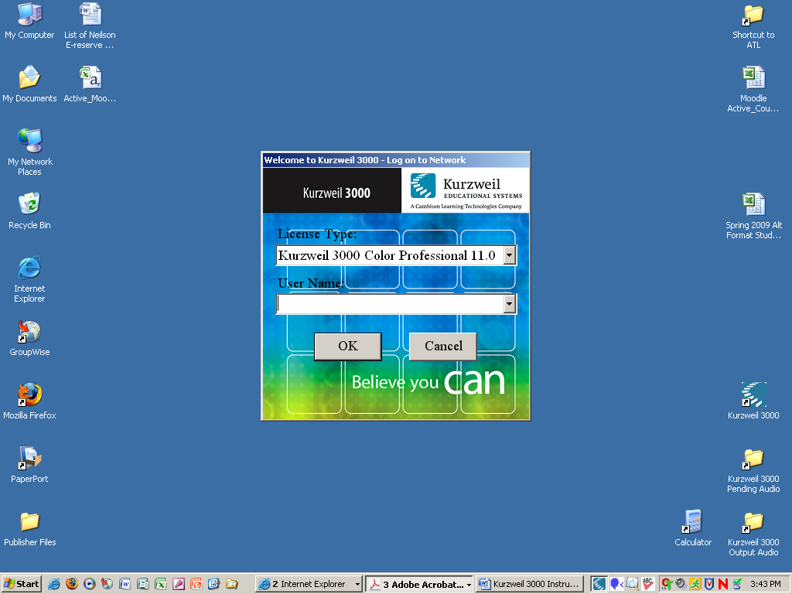 on the desktop.  This will bring up the screen seen to the right in figure 1.  In the “License Type” window, click the down arrow to the right of “Kurzweil 3000 Color Professional 11.0” to open the dropdown menu in figure 2. (below) | Figure 1
If you are just using Kurzweil to open files that have already been converted. Please select the “Kurzweil 3000 Learn Station 11.0” option.  If you will be either scanning your own materials, or converting PDF files such as from Moodle, please select the “Kurzweil 3000 B/W Professional 11.0” option.  Only if you need to scan or convert from a color file, should you select the “Kurzweil 3000 Color Professional 11.0” option. We have a limited number of licenses for each type. If the type you select is not available, you can simply make another selection. | 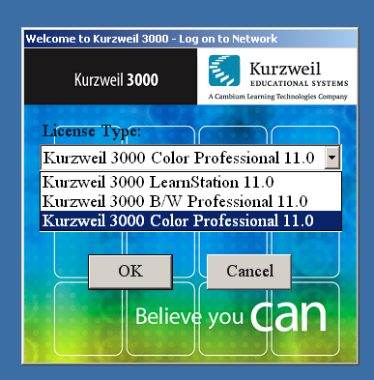  Figure 2
In the User Name window, you can type your first initial and lastname (if this is your first time). Else, use the dropdown arrow and select your user name from the list, then click the OK button to launch the Kurzweil software program.  Note: Having your own User Name creates a default folder for you under, “My Documents” →KESI -→Kurzweil 3000 →”User name”.  Your User Name also saves your individual setting preferences such as reading voice, speed, toolbar settings, etc. for the next time you launch the program. | 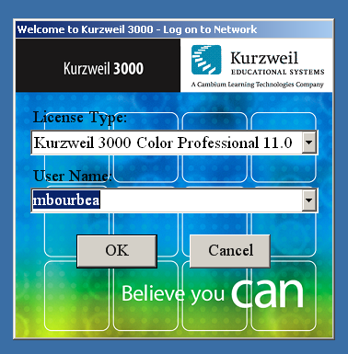  Figure 3

OPENING FILES

To open a file you can click the “open” icon, or use the File menu → Open file (or CTRL +O)
The default directory is the folder created for your username and it lives under, “My Documents” →KESI -→Kurzweil 3000 →”User name”. Or, go to the appropriate location to find the files you want to open.
If they are new KES files created by ODS, you will first find them by going to the ATL on ‘Rescent’\Home\Users (this is the H: home drive for the login-- username: ATL and password: ATLAB). Here you will find a folder named “Spring 2009 Scanned Text” which contains a folder for each course that ODS is scanning materials for. Find your particular course folder and find the file you want to open.

Once opened, please use the “save as” to save to your personal flash drive for future use. This will ensure that any highlighting, notes, or edits you’ve made to your files will not change and it will ensure that the original file does not get altered.

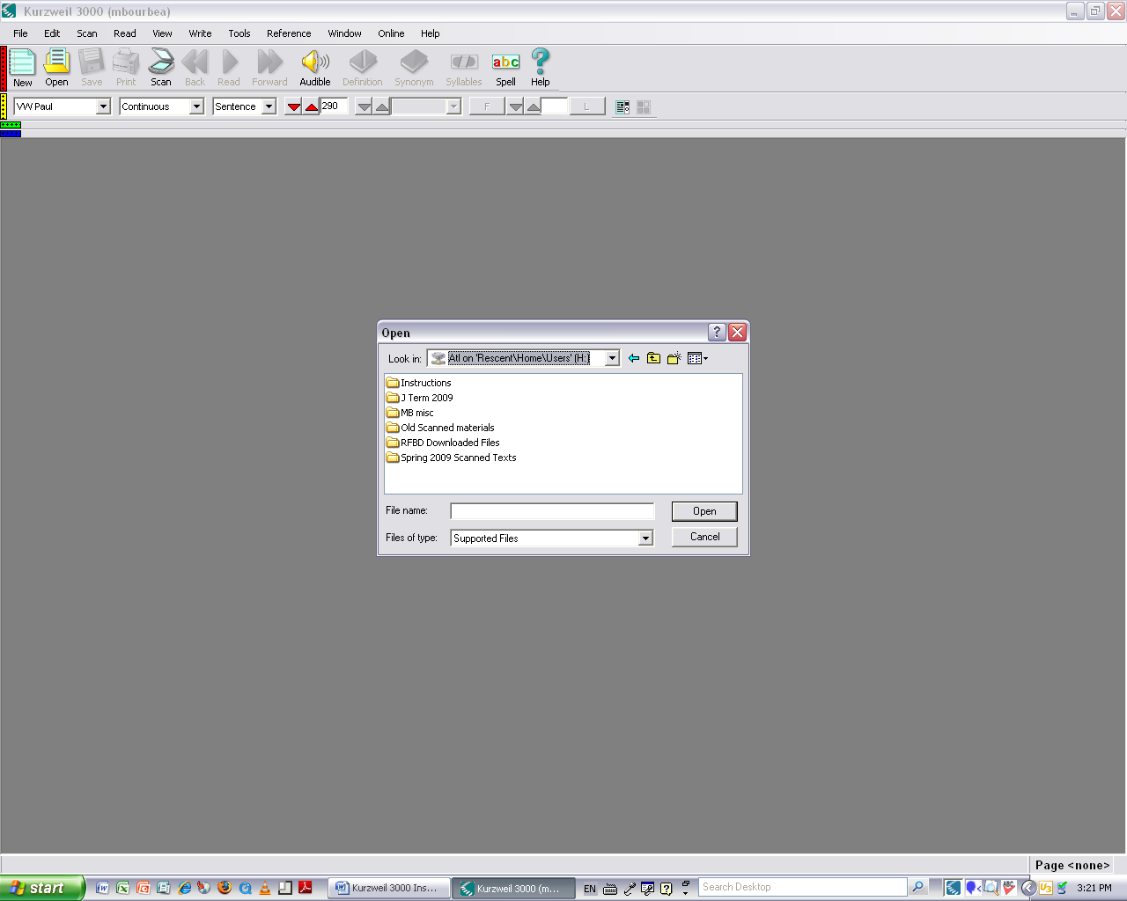

Sample of an open Kurzweil file

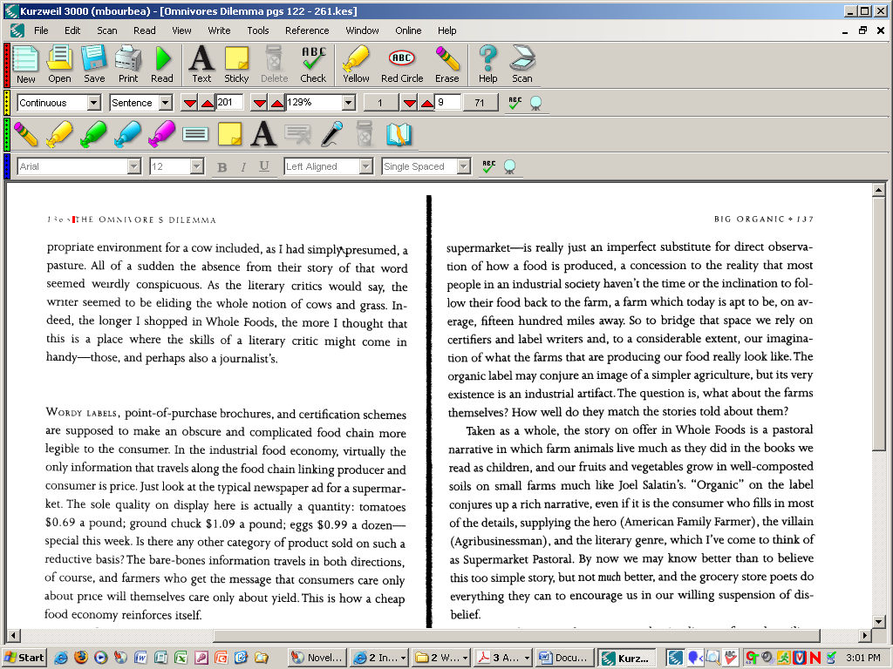

Kurzweil Toolbars

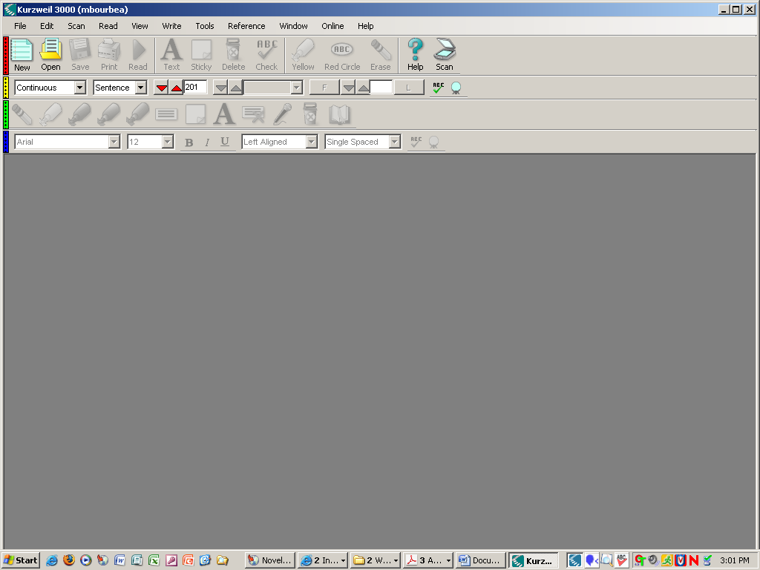
Toolbars:
Red-Main
Yellow-Reading
Green-Study Skills
Blue- Writing

To show or hide a toolbar, simply click on the leftmost color bar.

Note in the image below that the Highlighting toolbar (green) and Writing toolbar (blue) are now hidden.

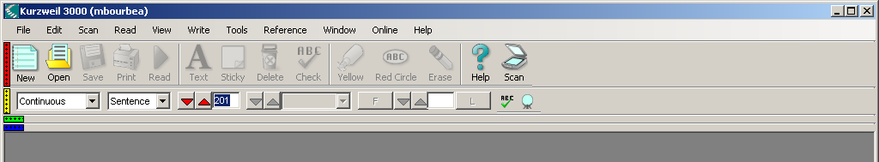

Reading Toolbar settings:

Let’s the user control how much Kurzweil highlights as it is reading.

Sample: Continuous by sentence

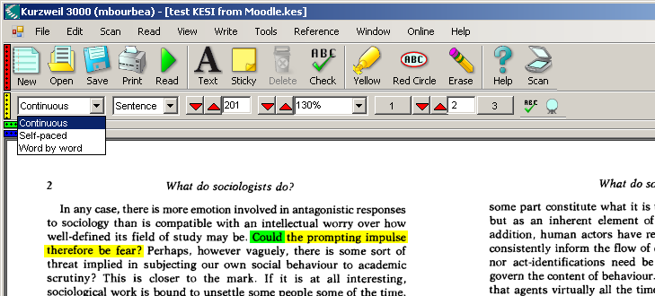

Sample: Continuous by Line

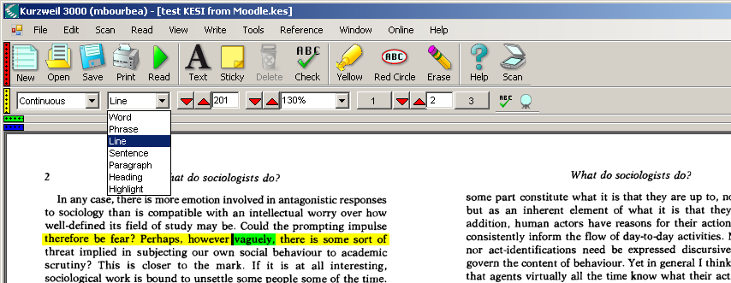
Sample: Continuous by Paragraph

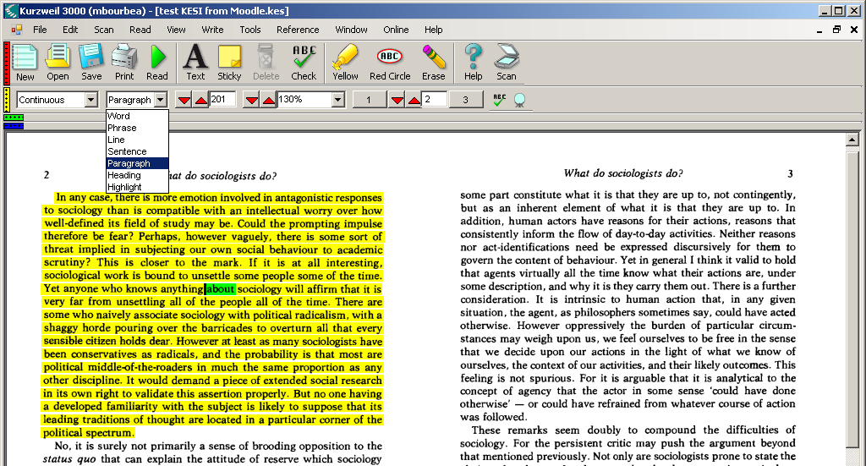

The Reading Toolbar is also where you can control:

- the speed, WPM (words per minute)
- The size of the image (% increase or decrease)
- And easily move through the pages using the up/down arrows or by typing in the page you want in the text window.

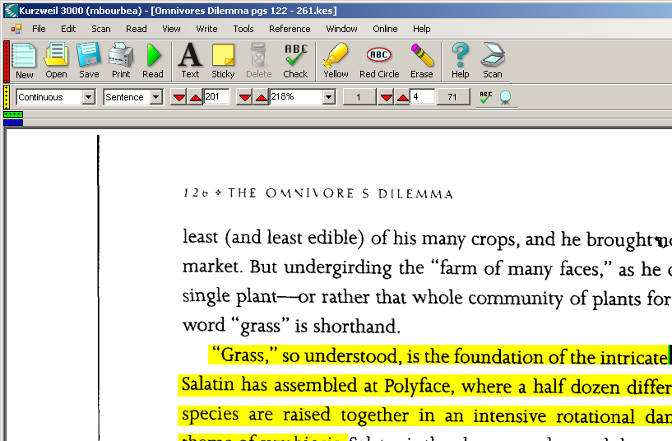
Instructions for Scanning directly into Kurzweil

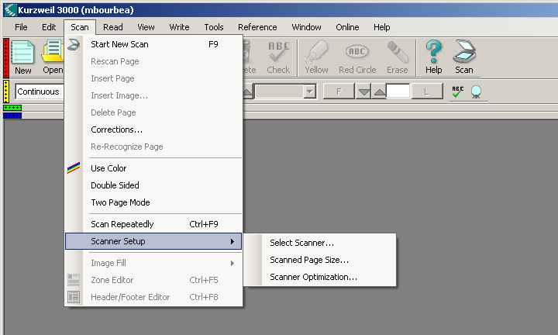

Scanned Page Size:
This lets you control how much of the scanner bed is used. If you are scanning a small paperback, you need only scan the portion of the flatbed that is covers. This speeds up the scanning process by not capturing more image space then necessary.

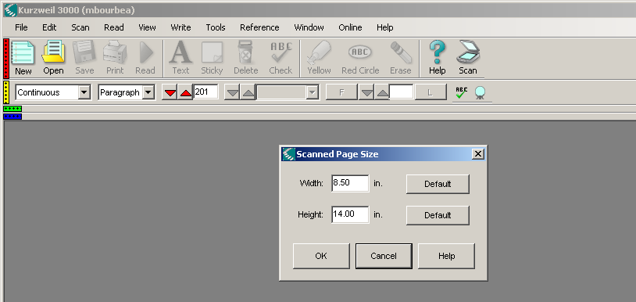

Note: you will want to change these setting to match what you are scanning to save scanning time. For instance, change height to 11.00 in for a standard letter size paper or book. You can change these both to smaller dimensions if you are scanning a paperback for instance.
Apply Toolbar Sets

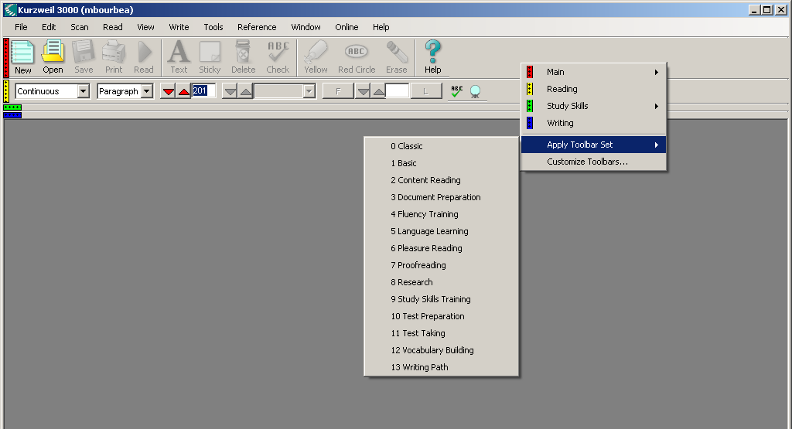

Customize Toolbars:

Allows you to customize what icons appear on each of your toolbars. You can add as much or as little as you need to use.

