Victor Reader Playback Software for listening to RFBD books on CD
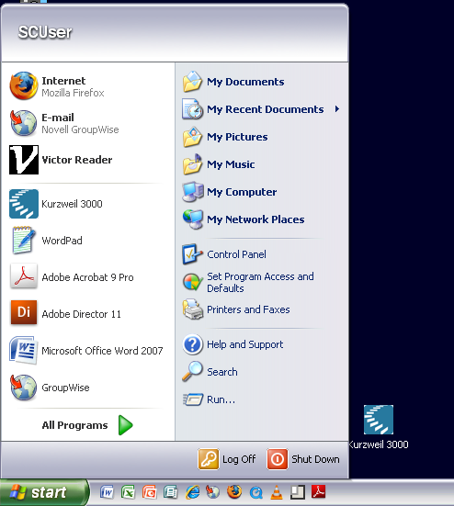
Click on the Start Menu and then Click on the Victor Reader icon to launch the program.
The first screen will have an “Open Book” dialog box.
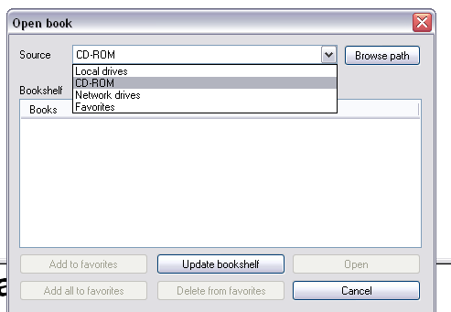

- Place your CD into the CD-drive in the front of the computer.
- Use the “Source” dropdown menu to select the CD-ROM drive, then click “Update bookshelf” button.

- Select your book from the Bookshelf window and then click “OPEN”
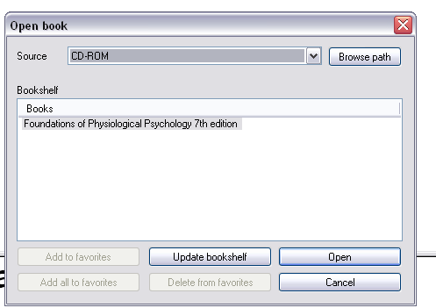

- Once the software loads your CD, it will ask you to enter your RFBD
authorization number (7323).
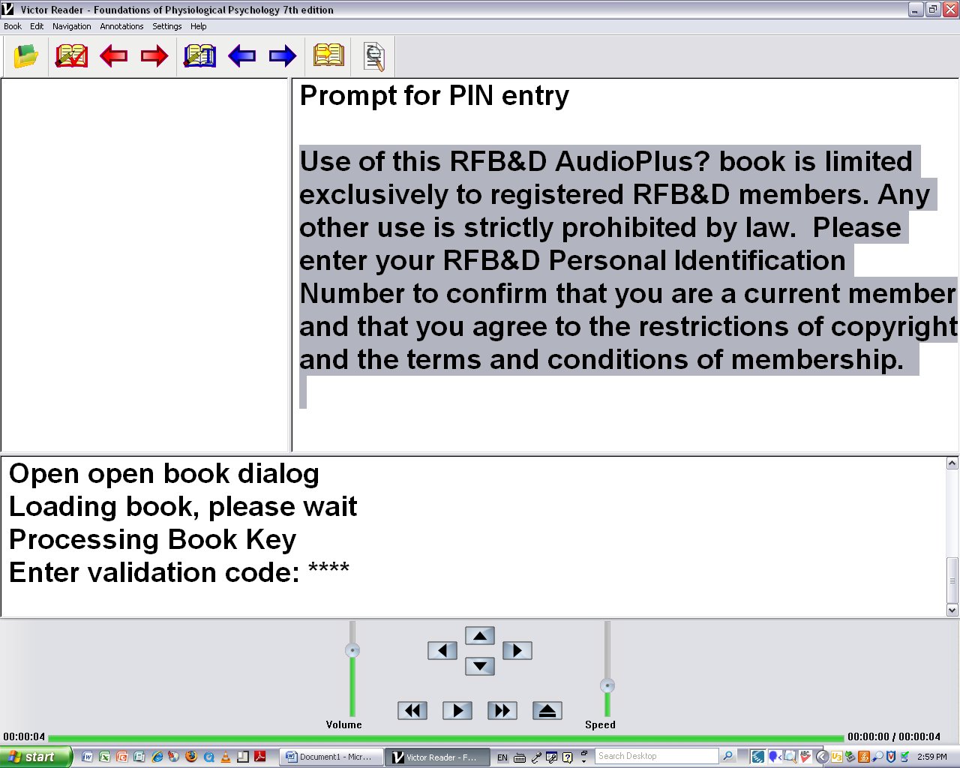
The authorization # is 7323

Now that your book has loaded, you can begin reading it by using the “go to page” icon on
the top menu.
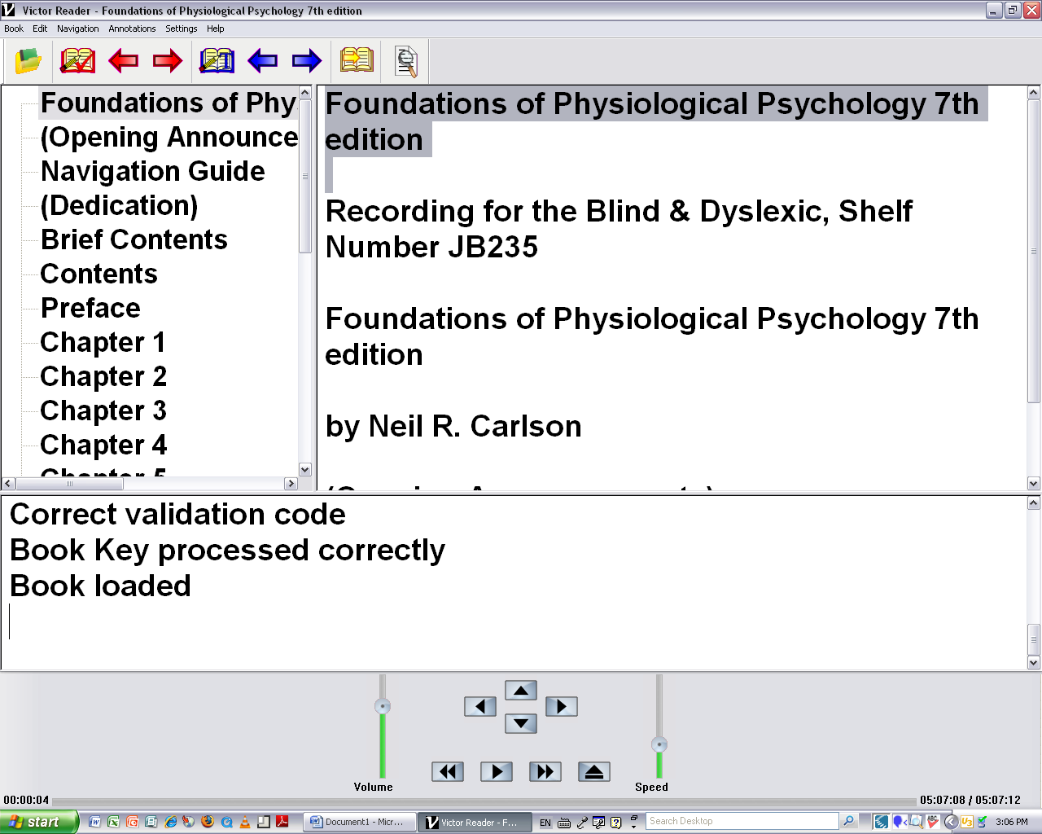

You can adjust the playback speed by adjusting the slider. Or by pressing the
S key to increase the speed and the Shift + S key to decrease the speed.

For further information about using the Victor Reader Software, you can reference the
“How to Use the Victor Reader Playback Software” handout.

